Low-temperature Synthesis of Large-area Films of Molybdenum Trioxide Microbelts in Air and the Dependence of their Field Emission Performance on Growth Condition
Dongmei Ban, Ningsheng Xu*, Shaozhi Deng, Jun Chen, Juncong She
State Key Lab of Optoelectronic Materials and Technologies, Guangdong Province Key laboratory of Display Material and Technology, School of Physics and Engineering, Sun Yat-sen University, Guangdong 510275, China
[Manuscript received March 24, 2011, in revised form July 28, 2011]
* Corresponding author. Prof., Ph.D.; Tel.: +86 20 84110916; Fax: +86 20 84037855; E-mail address: stsxns@mail.sysu.edu.cn (N.S. Xu).

We demonstrate a simple method for preparation of large-area films of molybdenum trioxide (MoO₃) microbelts. It is found that such films may be grown on ITO glasses or silicon substrates at low temperatures by thermal evaporation deposition in air without using catalyst. Field emission measurements show that the turn-on field of the MoO₃ microbelts may be as low as 2.2 V/m required to obtain a current density of 10 A/cm². The combination of the simplicity of the growth method and the attractive field emission performance leads one to consider it as a potential low-cost technique for preparation of large-area field emission cold cathode material.

KEY WORDS: Field emission; Large-area film; Molybdenum trioxide; Microstructures and synthesis
- Introduction
Molybdenum trioxide (MoO₃) is an interesting photochromic and electrochromic material, attractive for information display, sensor device and smart window^{[1−6]}. In addition, it is a good precursor for the synthesis of many other important materials, such as MoS₂, MoSe₂, Mo, and host-guest compounds^{[7−10]}. Recently the attractive field emission properties of MoO3 nanostructures such as nanoflowers^{[11]}, nanowires^{[12,13]} and nanobelts^{[14]} have been reported and thus they may be considered as potential cold cathode material applicable in field emission display^{[15]}, lighting device^{[16]} and plasma source^{[17]}. In order to develop techniques for control growth, the synthesis method and the growth mechanism of MoO₃ nanostructures have been a topic of investigation^{[11−14,18−22]}. One issue is about how to prepare a large-area film of MoO₃ nanostructures. Many related synthesis methods reported so far require vacuum conditions, and/or high growth temperature, and it will not be easy to develop these methods for preparation of large-area film. In the present study, we investigated the possibility of growth of large-area MoO₃ microbelts on ITO glasses or silicon substrates at low temperature and without catalyst. The results reported here are in particular relevant to field emission display or smart windows.
- Experimental
Our samples were prepared in a commercial infrared sintering furnace, which comprises 6 temperature zones. The length of each heating zone is 35 cm, and the width is 30 cm. The temperatures in each zone can be changed from room temperature to 1000ºC. Fig. 1 illustrates the arrangement of sample and evaporation source for our present study. When the furnace is heated and reaches the set temperatures, the substrates and the quartz boat containing Mo powders are carried to the set zones by the transmission belt from the entrance. The source materials are placed in the high temperature zone and the substrate in the low temperature one. The materials, which vapor from the source, are deposited on the substrate since it has lower temperature. In our method, MoO₃ microbelts grow in air and do not involve the use of other protection gases. The advantages of using a commercial infrared sintering furnace include: (1) the substrate area can be very large; (2) easy to change deposition temperatures using the combination of different temperature zones; (3) uniformity in the temperature inside the furnace.
Our sample preparation procedure is as below. ITO glasses or silicon substrates were washed with acetone and then with alcohol in an ultrasonic cleaner. The temperatures of Zone 1 to 6 were set to 200, 200, 350, 700, 700 and 100 ºC and heated, respectively. The substrate was placed in Zone 2 and the vapor source in Zone 5. They were then kept in their zones for 60 minutes. Finally, all the temperature zones were allowed to decrease gradually to room temperature. The substrate appeared white after deposition.
The as-prepared products were characterized and analyzed by using X-ray diffraction spectroscopy (D/max 2200 vpc apparatus with CuKα radiation), scanning electron microscopy (SEM: Quanta 400F), and high-resolution transmission electron microscopy (HRTEM: JEM-2010HR).
3. Results and Discussion
3.1 Morphology and structure
For the present study, the as-prepared samples have an area of about 3 cm×3 cm. The SEM image in Fig. 2(a) shows that the MoO3 microbelts exhibit a wide range of widths, ranging from 500 nm to 2 m, with thickness of about 100 nm. The length of microbelts may exceed 10 m (Fig. 2(b)). The XRD pattern of the MoO₃ microbelts is given in Fig. 2(c), and the diffraction peaks can be indexed to the MoO3 orthorhombic structure with the lattice parameters: a=0.396 nm, b=1.386 nm, c=0.37 nm (JCPDS: 5-0508). Fig. 2(d) is the low-magnification TEM image of the MoO3 microbelts. The free end of a MoO₃ microbelt has been seen to have edges and corners, which may give electrical field enhancement useful to field emission. The high resolution TEM (HRTEM) image (Fig. 2(e)) shows the two sets of parallel fringes with a spacing of 0.396 nm and 0.37 nm corresponding to the (100) and (001) planes, respectively. The SAED patterns (inset, Fig. 2(e)) recorded perpendicular to the growth axis of a single MoO₃ microbelts is attributed to the [001] zone axis diffraction of orthorhombic MoO₃. The HRTEM image also shows the existence of defects and the growth at low substrate temperature is the possible reason.
3.2 Growth mechanism
We assume that the growth mechanism follows a vapor-solid process, which is similar to the growth of MoO₃ nanowires reported early^{[12,13]}. The oxide vapor, evaporated from the starting oxide at a higher temperature zone, directly deposits on a substrate at a lower temperature region, resulting in the nucleation and growth by continuously receiving the incoming vapor. In order to understand how the MoO₃ microbelt is formed, we examine the anisotropy orthorhombic structure of MoO₃ (Fig. 2(f)). It illustrates in details the distorted octahedral configuration with a corner sharing in the direction of the a-axis (O (2) of the Fig. 2(f)), a zigzag edge sharing in the direction of the c-axis (O (3) of the Fig. 2(f)) and an unshared oxygen atom in b-axis (O (1) of Fig. 2(f)). For the orthorhombic MoO₃, the (001) low-index surfaces are likely to have the lowest energy, and thus, the MoO₃ microstructures are likely to grow on (001) facets, which is a common phenomenon in the MoO₃ microstructures^{[12,13,18]}. The substantial difference of the bonding configuration along [010] and [100] directions will have notably different ability of absorbing the incoming molecules of the source, leading to difference in growth rate^{[14]}, and thus, the MoO₃ microbelt forms.
3.3 Field emission property
The field emission measurements of the MoO₃ microbelts were carried out in a vacuum chamber of ~5.0×10⁻⁷ torr at room temperature. The substrate with microbelts was first adhered to the surface of an oxygen-free, high-conductivity copper disc. A transparent anode, consisting of a quartz plate 4 cm in diameter and coated with conducting Indium doped tin oxide film, was placed in front of, and parallel to, the surface of the sample cathode.
In order to find the optimal conditions for samples with high performance of field emission, we studied the dependence of their field emission characteristics on the growth duration. We found that the length and thickness of the MoO₃ microbelts were affected by growth duration. The SEM image of the MoO₃ microbelt films with different growth duration are shown as Fig. 3. The insets are the high resolution SEM images to show more details of the morphology of the MoO₃ microbelts. Fig. 4 shows their field emission J-E and the corresponding F-N curves. It is obvious that a film having a higher aspect ratio has a lower turn-on field. The corresponding relationship may be seen in Table 1, which lists the length, the width and aspect ratio of each sample of different growth duration and the corresponding turn-on field. Their aspect ratios are about 1.3, 4, 6.7, and 10 corresponding to the growth duration of 1, 3, 10 and 60 min respectively. The best value of turn-on field is 2.2 V/m, and is for the sample of the longest duration (60 min) and the highest aspect ratio (10). The turn-on fields from our samples of MoO₃ microbelts are found to be lower than that of the MoO3 nanobelt (8.7 V/m at 10 A/cm²)^{[14]}, nanoflower (4.3 V/m at 10 A/cm²)^{[11]} and of MoO₃ nanowires (3.5 V/m at 10 A/cm²)^{[12,13]}, which were reported early. The results indicate that the MoO₃ microbelts are a good candidate as cold-cathode material. In addition, Fig. 5 shows the optical images of field emission site distribution for the different samples, and one may see that emission sites are distributed over the entire sample surface. Finally, the emission stability of our samples of MoO₃ microbelt was studied. Fig. 6 shows a typical field emission I-t curve recorded for 3 h at a constant electric field of 10.7 V/m for an average emission current of 500. No significant decrease of current was observed and the fluctuation was about 2%.
- Conclusion
We have demonstrated that large-area films of crystalline MoO₃ microbelts may be grown on ITO glasses or silicon substrates by thermal evaporation in air using a commercial infrared sintering furnace. This method is simple and can be of high yield. The MoO₃ microbetls are of orthorhombic structure with a=0.396 nm, b=1.386 nm, c=0.37 nm, and the growth direction is [001]. By controlling the growth duration, films of MoO₃ microbelt with different aspect ratio may be prepared. The longer growth duration leads to longer length and higher aspect ratio of the MoO₃ microbelts, and the higher of their aspect ratio the lower their turn-on field is. The observed turn-on fields of our samples of MoO₃ microbelts are lower than MoO₃ nanobelts and nanowires previously reported. In addition, the films of MoO₃ microbelts are found to have stable field emission characteristic.
Acknowledgments
The authors gratefully acknowledge the financial support of the project from the National Natural Science Foundation of China (No. U0634002), and the National Basic Research Program of China (No. 2003CB314701).

REFERENCES
[1] J. van der Geer, J.A.J. Hanraads, R.A. Lupton, J. Sci. Commun. 163 (2000) 51–59.
[2] Y. Zhang, L. Ren, M. Li, X. Lin, H.F. Zhao, K. Yang, J. Mater. Sci. Technol. 28 (2012) 769–772.
[3] W. Strunk Jr., E.B. White, The Elements of Style, third ed., Macmillan, New York, 1979.
[4] J.Q. Yu, Atlas of Binary Alloys Phase Diagram, Shanghai Scientific and Technical Publishers, Shanghai, 1983, pp. 334–339.
[5] G.R. Mettam, L.B. Adams, in: B.S. Jones, R.Z. Smith (Eds.), Introduction to the Electronic Age, E-Publishing, Inc., New York, 1994, pp. 281–304.
[6] Y. Sawaragi, S. Hirano, in: M. Jono, T. Inone (Eds.), Mechanical Behavior of Materials, Pergamon Press, London, 1992, pp. 589–594.
[7] F. Masuyama, L.B. Adams, in: Proceedings to the 4th International Conference on Advances in Materials Technology for Fossil Power Plants, Hilton Head Island, South Carolina, U.S., October 25–28, 2004.
[8] X.H. Ma, The Preparation and Property Research of Hydroxyapatite Flurescent Nano Particle, Ph.D. Thesis, Wuhan University of Technology, 2007. (in Chinese)
[9] K.L. Corwin, A Circularly-polarized Optical Dipole Trap and Other Developments in Laser Trapping of Atoms, Ph.D. Thesis, University of Colorado, 1999.
[11] C.G. Bai, L. Murr, W. Smith, A Novel Method for Preparing Al Base MMC, US Patent, No. 200101133, 2001.
[12] H.R. Sheikh, Z. Wang, L. Cormack, A.C. Bovik, Live Image Quality Assessment Database Release 2, http://live.ece.utexas.edu/research/quality, September 8, 2006.

Figure and table captions

Table 1 Turn-on fields of the MoO₃ microbelt films of different aspect ratios

Fig. 1 XRD patterns of samples with different durations: (a) 1 min, (b) 3 min, (c) 10 min

Fig. 2 SEM micrographs of samples with different durations: (a) 1 min, (b) 3 min, (c) 10 min, (d) 60 min

Table list:
Table 1 Turn-on fields of the MoO₃ microbelt films of different aspect ratios
 | Growth duration/min | Length/μm | Width/μm | Aspect  ratio | Field/(V/μm)
Sample 1 | 1 | 2 | 1.5 | 1.3 | 3.6
Sample 2 | 3 | 4 | 1 | 4 | 3.4
Sample 3 | 10 | 10 | 1.5 | 6.7 | 2.8
Sample 4 | 60 | 20 | 2 | 10 | 2.2

Figure list:

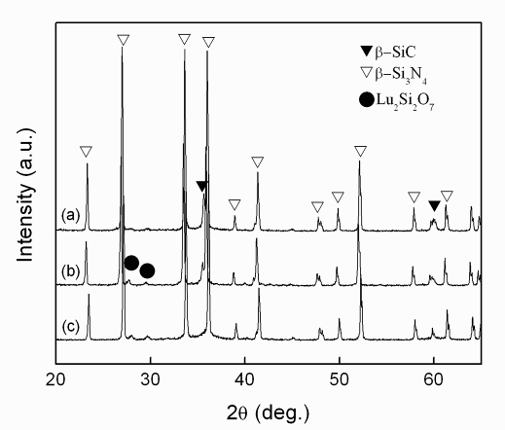

Fig. 1 XRD patterns of samples with different durations: (a) 1 min, (b) 3 min, (c) 10 min

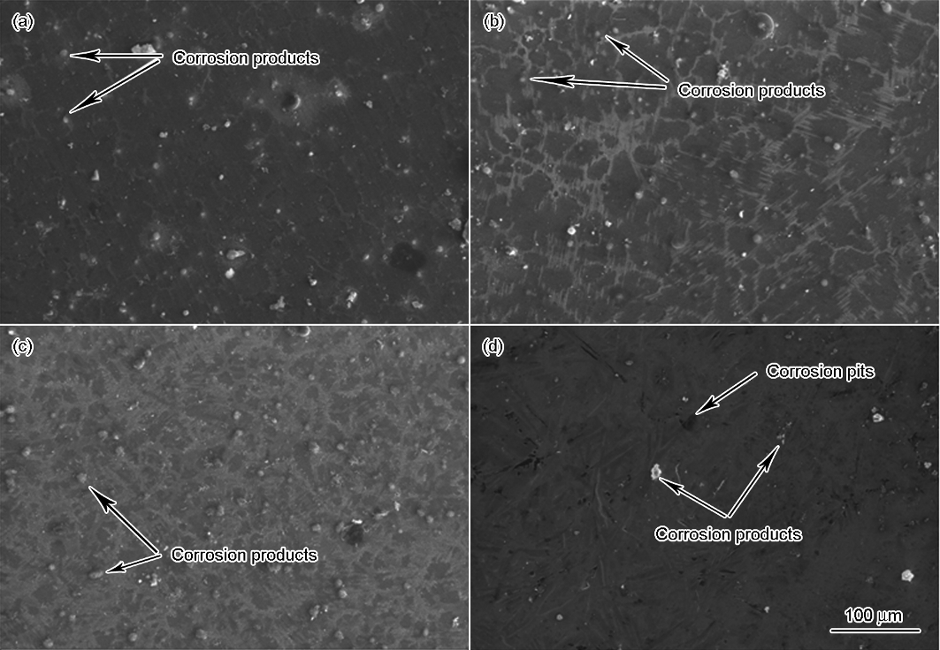

Fig. 2 SEM micrographs of samples with different durations: (a) 1 min, (b) 3 min, (c) 10 min, (d) 60 min

